
Herman Parish
Author Visit
Thursday, October 24, 2013

Herman Parish is the nephew of Amelia Bedelia's creator, Peggy Parish, and the author of fourteen books about Amelia Bedelia. He will be at Gullett on Thursday, October 24. He will be making presentations to all classes and autographing books for children who have purchased books. We will be taking orders for Amelia Bedelia books before his visit. If you wish to purchase a book, please:

- Fill out the form below and total your amount. Please fill out one form for each child.
- Put this form and payment in an envelope. Write your child’s name, teacher’s name, and AUTHOR VISIT on the front
- Payment can be made in the exact amount, in either cash or check made out to Barnes & Noble.
- Have your child bring the envelope to Ms. Gooch in the library.
Student :________________________Grade___Teacher____________

Name of book | Autograph book to: | Cost each | How many? | TOTAL
An Amelia Bedelia Celebration: Four Stories Tall |  | $21.64  Hardback
Amelia Bedelia Backpack Bundle |  | $10.80  Hardback
Happy Haunting, Amelia Bedelia |  | $4.32  Paperback
Amelia Bedelia  Talks Turkey |  | $4.32  Paperback
Amelia Bedelia  Means Business |  | $5.40  Paperback
Amelia Bedelia  Unleashed  ^{h} |  | $5.40 Paperback
Tax is included Make checks to Barnes & Noble
Grand Total:

The back of this paper tells about each book. To learn more about Amelia Bedelia visit the website: http://www.ameliabedeliabooks.com.
Check # ___________ or Cash ___________
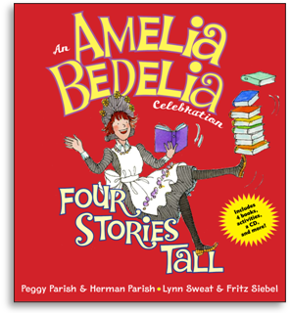
An Amelia Bedelia Celebration, Four Stories Tall

A treasure trove of Amelia Bedelia! This book includes four of Amelia Bedelia’s most beloved adventures. Two stories by Peggy Parish (Amelia Bedelia and Good Work, Amelia Bedelia) and two by Herman Parish (Good Driving, Amelia Bedelia and Bravo, Amelia Bedelia) along with related crafts, recipes, activities and all of the stories read on a CD.

Amelia Bedelia’s Backpack Bundle

This book has three back-to-school Amelia Bedelia stories, Amelia Bedelia’s Masterpiece, Amelia Bedelia’s Bookworm, and Amelia Bedelia, Rocket Scientist? Amelia Bedelia’s literal mishaps have delighted millions of readers young and old.
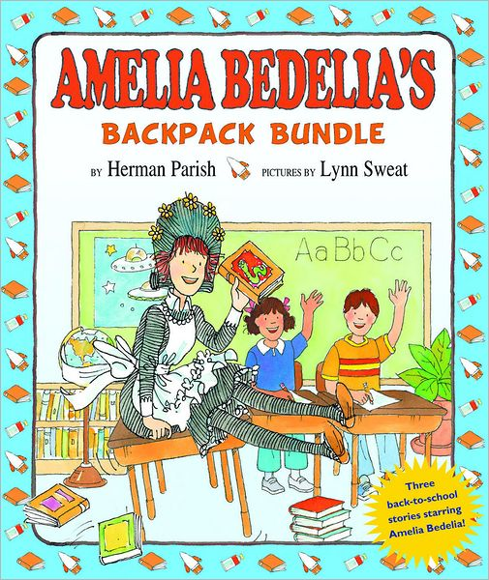

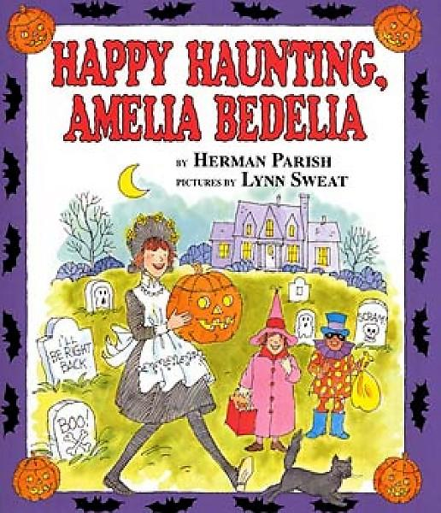
Happy Haunting, Amelia Bedelia
Preparing for a Halloween party, maid Amelia Bedelia is asked to crack a window (she uses a hammer) and add leaves to lengthen a table (she uses tree leaves). Otherwise Amelia's customary literal-mindedness is in short supply in a story whose main focus is the trick she plays on her boss.

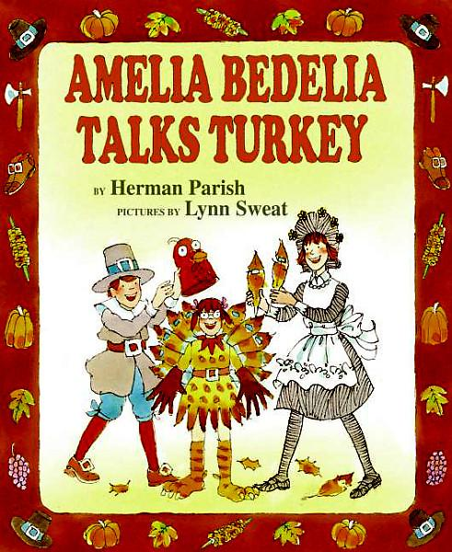
Amelia Bedelia Talks Turkey

Amelia Bedelia volunteers to fill in as the director of a third-grade Thanksgiving play, but she misunderstands everything from one girl's desire to play a big role to an opening night wish that she "break a leg."
Let's all give thanks for another hilarious Amelia Bedelia episode!

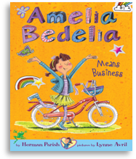
#1 Amelia Bedelia Means Business

Amelia Bedelia will do almost anything for a shiny new bicycle. To earn the money for it, she gets a variety of jobs with hilarious results. Will Amelia Bedelia ever get the bike of her dreams?

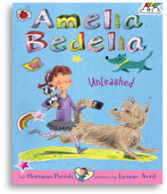
#2 Amelia Bedelia Unleashed

Amelia Bedelia's parents promise to let her have a dog. With hundreds of types to choose from, Amelia Bedelia has to do her dog homework. Is she picking the perfect puppy or barking up the wrong tree?

